* **Thumb rules** while creating a test automation framework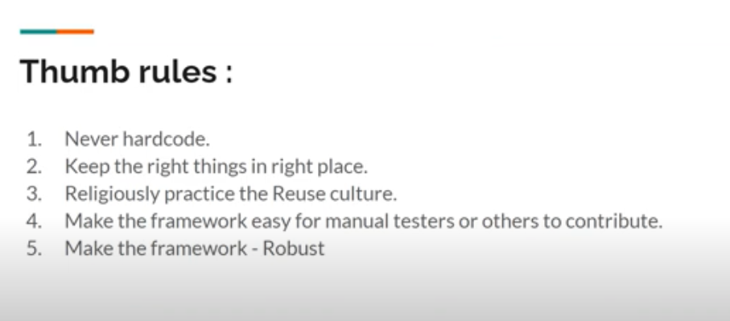
* While creating a Maven project, the **groupID** means the organization’s name/clients name for which the project is being created. **ArtifactID** must be related to what our project/artifact is all about.
* In the below screenshot we can see a @Test method. If we are using the browser driver instead of WebDriverManager API, it is a best practice to store it in a folder under **src/test/resources**. Additionally while giving the path we need to use **/** so that irrespective of the operating system the path would be picked. It is also a good practice to give **System.getProperty(“user.dir”)** before the path, which would make sure that while executing the existing project directory is accessed by default. Below is a sample code, the actual driver initialization would be in DriverFactory class.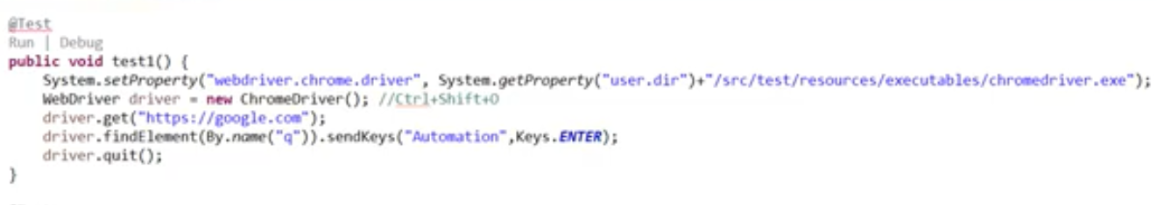
* Common naming standards

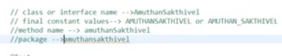

* **Creating a Constants class** -> We can create a separate class named for example as **FrameworkConstants** in src/main/java. This class can be used to store the variables for which the values never change once defined. Below are some of the features –

1. The **FrameworkConstants class must be final** so that it cannot be inherited by another class using extends keyword.
2. The variables defined in FrameworkConstants class **must be private, static and final**. Additionally the variable name must be in **CAPS**.
3. As the **constant variables are private** in nature we need to create getter methods to access the constant variable value from another class. The setter method cannot be created because the constant variable is already final in nature hence the value is already set and later we can't change the value so setters cannot be used.
4. As the **constant variables are static** in nature, the constant variables will have unique memory allocation and to access it, the object of FrameworkConstants class need not be created.
5. As the **constant variables are final** in nature, hence the value of the variable cannot be changed.
6. We can add a **private constructor in FrameworkConstants class**, this would restrict anyone from creating an object of the FrameworkConstants class in any other class.
7. It is better to not keep things like the application url value in FrameworkConstants class, instead keep them in properties file as it would be easy for non technical people to change it later if we want to run the framework in another environment.
8. We can keep the Explicit wait seconds value in constant class.

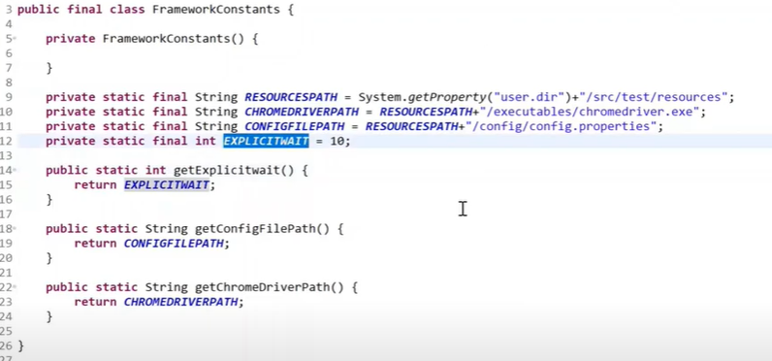

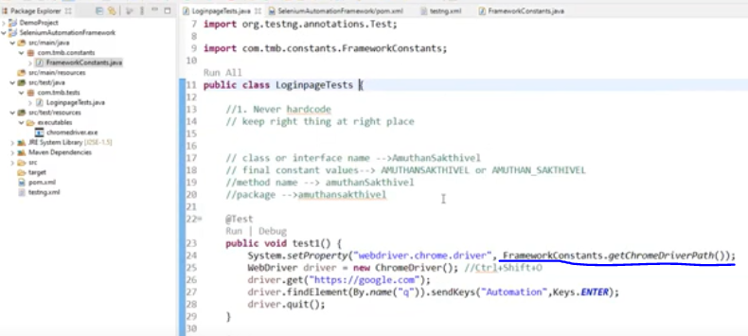

* The Test classes in the framework which follows a Page Object Model pattern can be made as **final** as these test classes need not be extended by other classes. Additionally we can also add a **private constructor** for the test class, which would basically prevent creation of object of the test class in any other classes.
* The BaseTest class which contains the @BeforeMethod and @AfterMethod annotations cannot be made as final as this class is extended by other Test classes to run the before and after annotations. We cannot create the constructor of the BaseTest class as private as it is being inherited by other Test classes, but we can restrict the scope to be **Protected**.

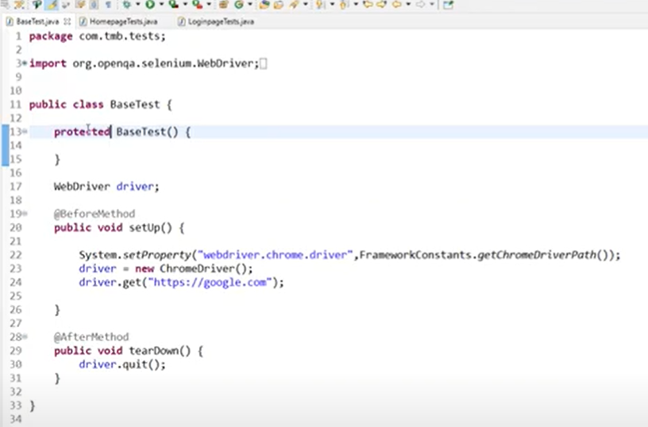

We will move the driver initialization shown in the above screenshot from BaseTest to DriverFactory class to stay true to the Single Responsibility Pattern.

* In DriverFactory class, make the initDriver() and quitDriver() method as static and subsequently also make the WebDriver declaration as static.
* The BaseTest class in testNG is similar to the Hooks class in Cucumber, both these classes will have the Before and After annotations to run the specific precondition and postconditions.

1. Once the driver initialization and driver quitting are moved to the DriverFactory class, we can call the initDriver() and the quitDriver() methods in the respective @BeforeMethod and @AfterMethod in the BaseTest class.
2. If a person accidentally calls the initDriver() method in a new @Test method without knowing that it is being handled in the @BeforeMethod of the BaseTest class, then chances are that we would see another browser window opening up.

To restrict the above scenario we need to add null check in the initDriver() method as in the below screenshot.

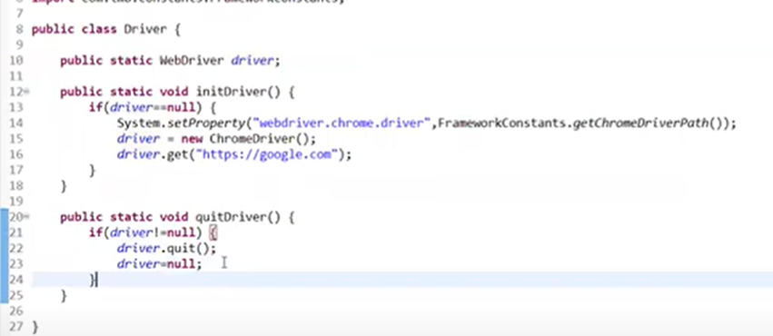

1. In the above screenshot, we are also adding driver not null check in quitDriver() and setting the driver as null after quit() is called.
2. We can also replace the checks for null check using default Objects method in Java 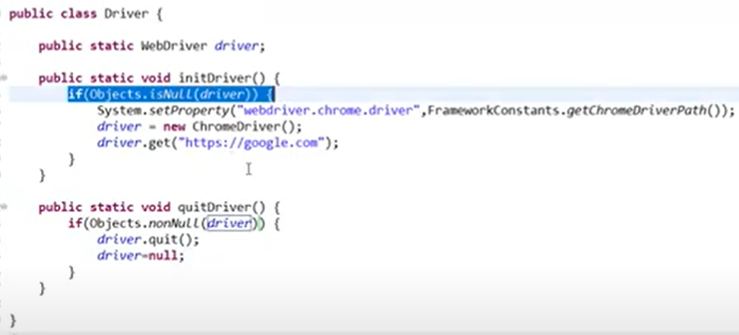

* **ThreadSafety issues**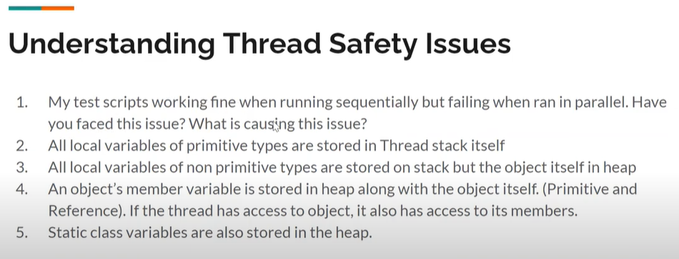

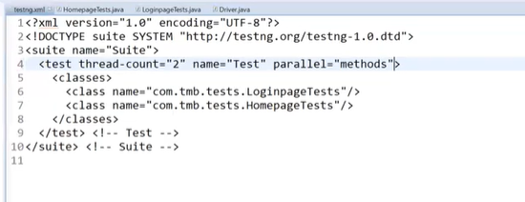

In the above testng.xml we can see that the **thread-count** and **parallel** attributes decide how tests can be run in parallel, but there is a catch. There are scenarios when one browser window will proceed with the execution whereas another window will load but fail to move forward and we would get an exception such as staleelementreference exception.

This is because threads can easily access the class variables(static/instance) as they are stored in the heap memory (in the case of selenium, this variable would be WebDriver).

To understand more about this we need to first go through how memory management works in Java, which is illustrated in the below image.

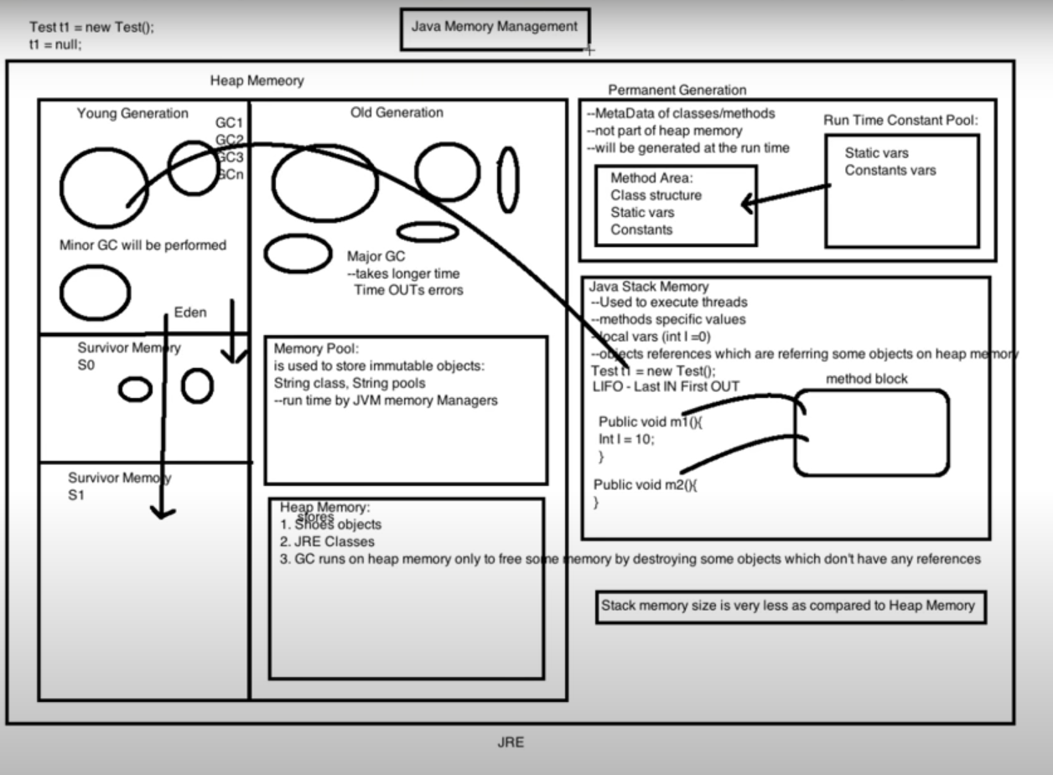

When the objects are created then the reference variable is stored in the Stack whereas the object itself is stored in the Heap.

In Java, the local variables are thread safe in nature whereas the class variables are not thread safe by default.

In case of local variables to be more detail, the local variables which are of primitive data type gets stored in the Stack along with its values(int a=2), whereas for a non primitive local variable the reference variable would be in the Stack but the value would be in Heap (like String s=”Selenium“). How these 2 are connected is, the reference variable stored in the Stack would be having a hashcode which would point to the object of the same which is present in the Heap and thereby the connection is established.

As the local primitive variables and its values are stored in the Stack itself and there is no hashcode value pointing to the Heap hence it is considered as thread-safe. On the other hand, the class variables and the non primitive local variables are not thread-safe.

Coming to the class variables, the object or the value of the same is always stored in the Heap memory and not in the Stack. In case of test automation we always initialize WebDriver as a static class variable and hence it becomes thread-safe and the need of **ThreadLocal** arises.

* **ThreadLocal** **Class**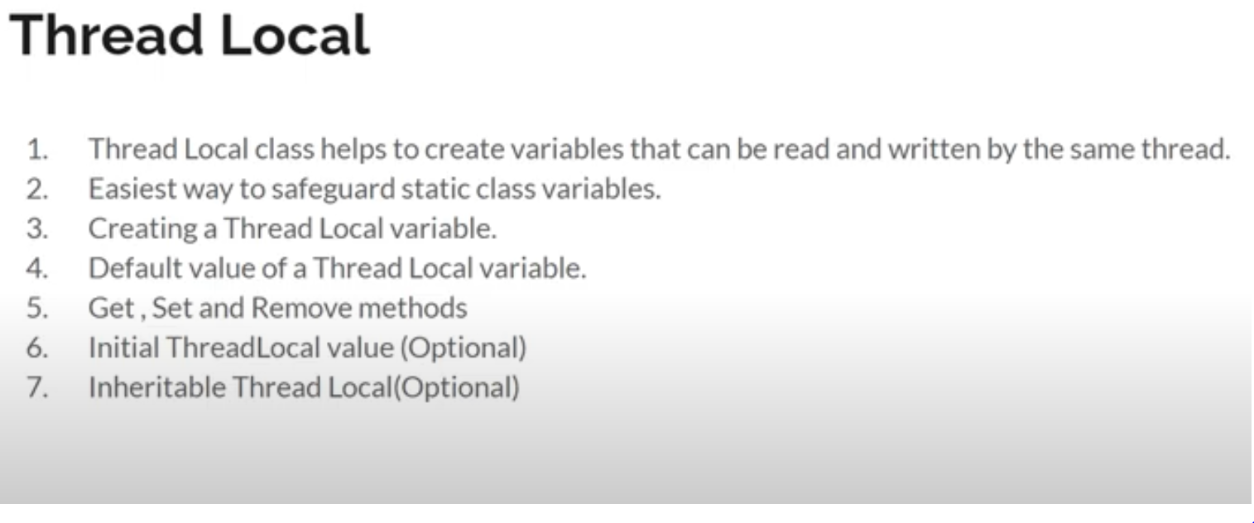

**ThreadLocal class** has three main methods – set, get and remove.

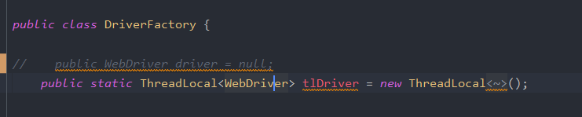

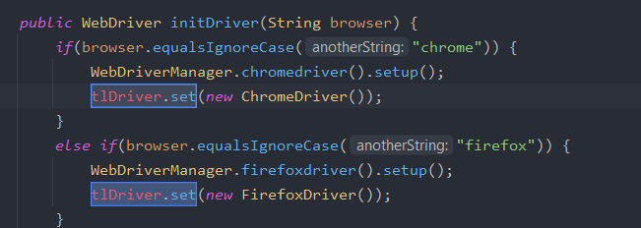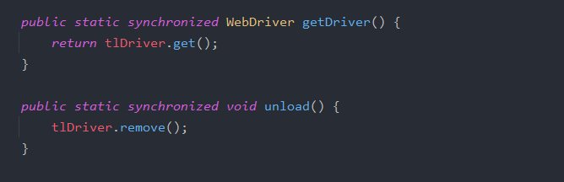

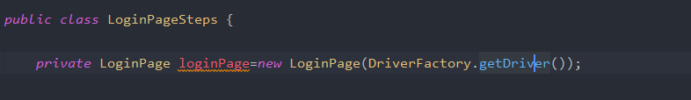

Once we have defined the remove method inside a custom method unload(), in the below image call the same instead of driver=null.

Also in the initDriver() and the quitDriver() methods given in the below image we need to replace driver in the if condition to tlDriver.get() method.

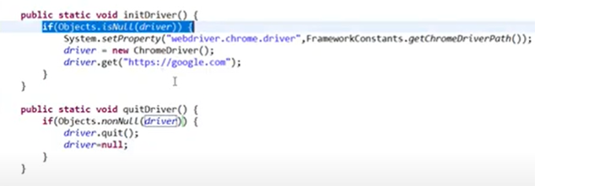

For further maintaining the Single Responsibility Pattern, it is better to put the set, get and remove methods in a separate class (ThreadLocalDrivers.class) and call them in the DriverFactory class using the classname of that class. (ex ThreadLocalDrivers.unload() ).

* **Changing the access modifier from public to protected in BaseTest class methods**

As the methods in the BaseTest class is accessed by other Test classes by extending the BaseTest class, hence we can make sure that the @Before and @After methods would be accessed only by the Test classes hence we can make the access modifiers of the same as protected.

Best Practice to use access modifiers -> private, protected, default and if these are not compatible due to our login then only make them as public.

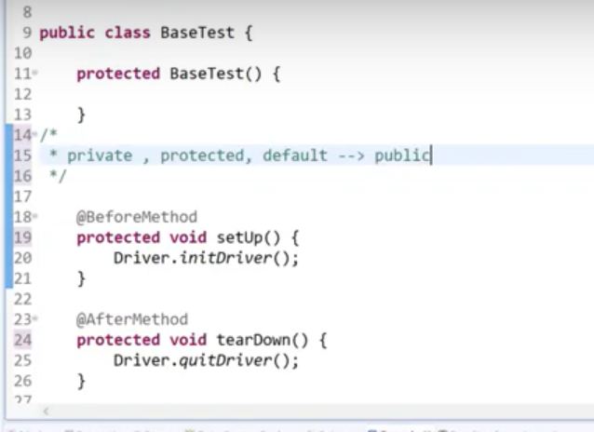

* **Properties File**

Here we have listed out 2 different approaches of initializing and calling the properties file.

First approach

We create the Config Reader class, add a method initProperties() to initialize the properties and this method would return a Properties object.

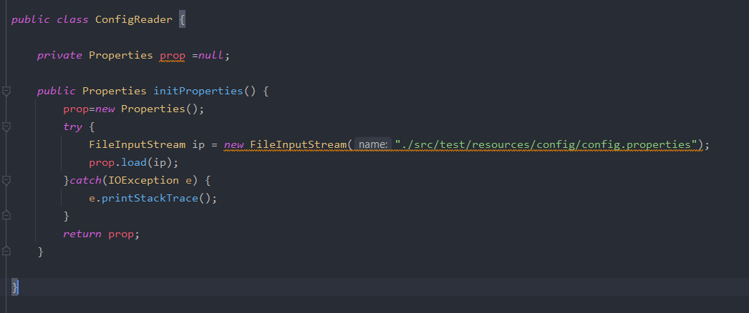

Later in the below ApplicationHooks class, we are creating an object of the of ConfigReader class and call the initProperties() method and store it in a prop object.

In the next step we are using the prop.getProperty method and passing the ‘browser’ which is the key in the config.properties file.

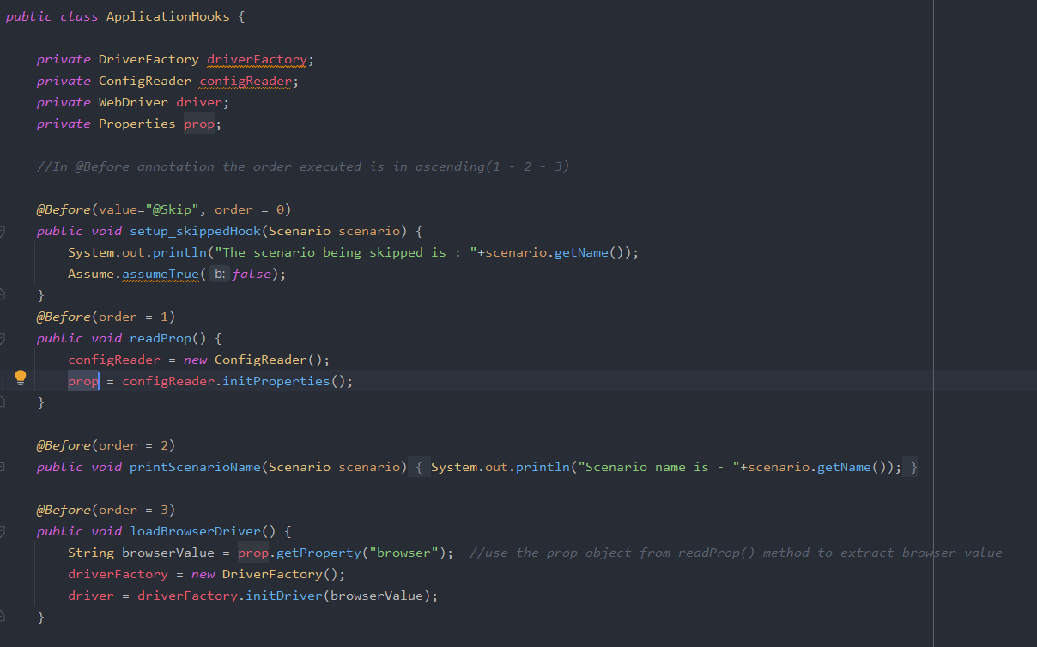

**Best Practice -**  While accessing data from the properties file using getProperty method, it is advisable to use .trim() method to trim the leading and trailing spaces.

Second approach

We create the Config Reader class(here name is ReadPropertyFile) which is final in nature so that it cannot be inherited, create a private constructor so that object of this class cannot be unnecessarily created in other classes. Add a parameterized static method getValue() to initialize the properties and this method would return the value from the properties file as well.

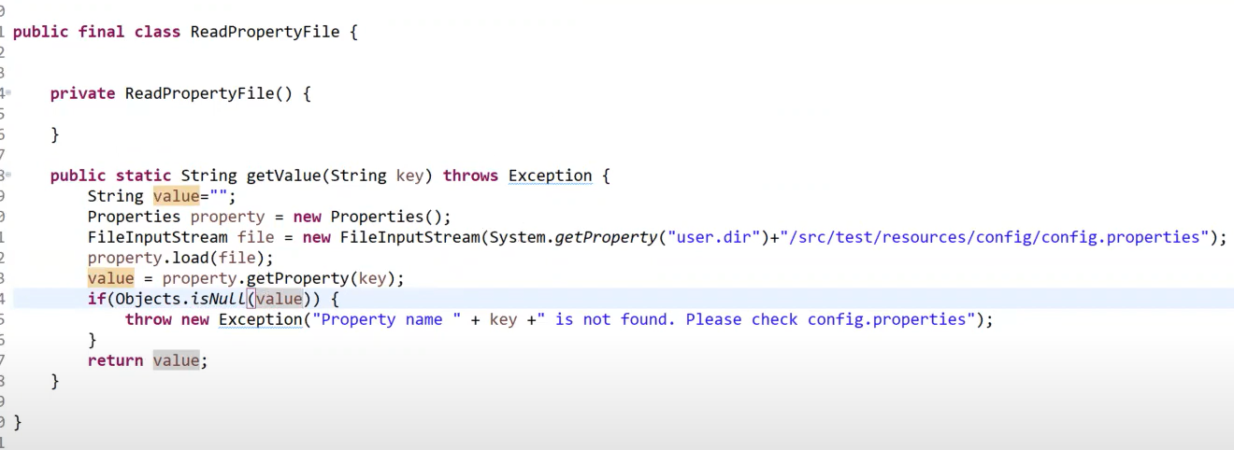

In the below method we can see the method is called with the parameter as the key in the properties file.

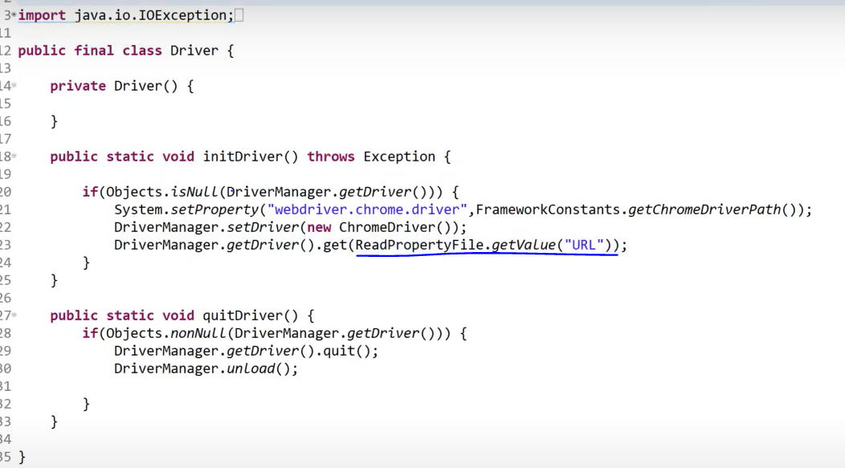

Both the above approaches are good, but the second approach is more efficient and implementes the framework thumb rules in better manner. Only disadvantage of second approach is that each time when a value needs to be accessed then we have to create FileInputStream and access the file which reduces the framework efficiency when we are accessing lot of data from the properties file.

The solution to the above disadvantage is by using **Static blocks** in Java.

* **Static Blocks in Java**

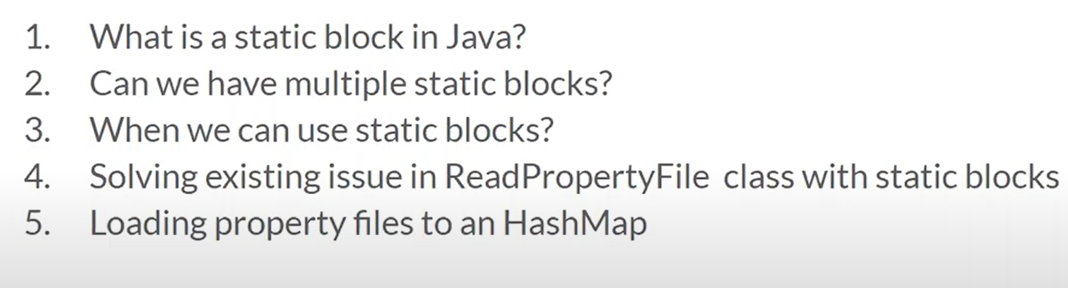

Static block is used to initialize the all the static variables of a class in one go.

We can also **have multiple static blocks** in the same class.

Calling the same method again and again (here we are referring to initializing the FileinputStream for accessing the Properties file) such a process is called **Lazy Initialization** and when moving the repetative initialization to a static block then it is called **Eager Initialization**.

**In the below image we have updated the ConfigReader class by incorporating a Static Block which would do the initialization of the FileInputStream once the class is executed and will stay in the memory hence there is no need to initialize the same again and again.**

**Thumb rule** – Whenever there is a parameterized method and it accepts a String value then it is always a best practice to check if the incoming String value is null. To follow this best practice we have updated the getValue method and added an additional condition to check if key is null and if so then it would throw an exception.

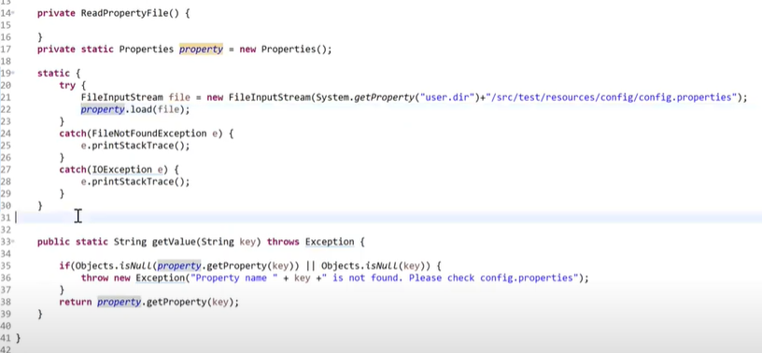

We can also move the property file path into Constants class to stay true to single responsibility pattern.

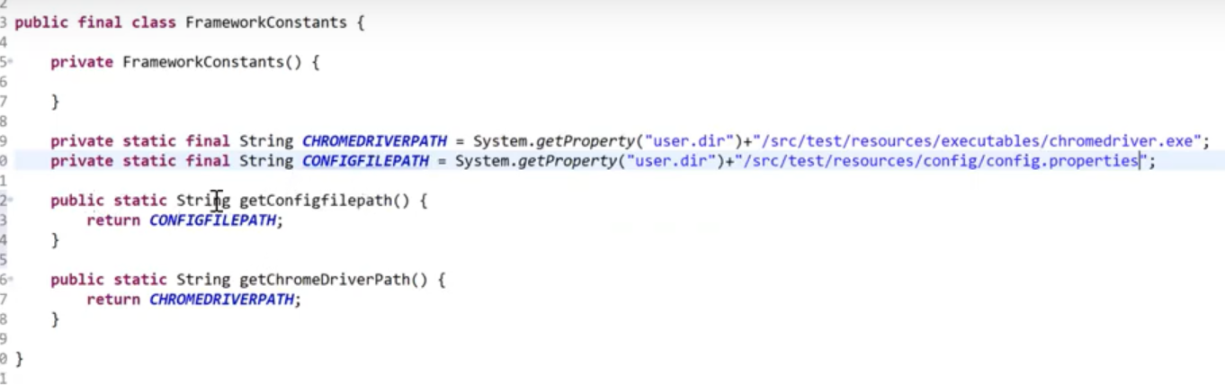

* **Adding Hashmap with Static Blocks**

Whenever there is a considerable amount of data in the config.properties file then we can improve the implementation by adding the data into Hashmap and accessing it from there. (not mandatory as Static Block implementation would suffice).

**Using keySet()**

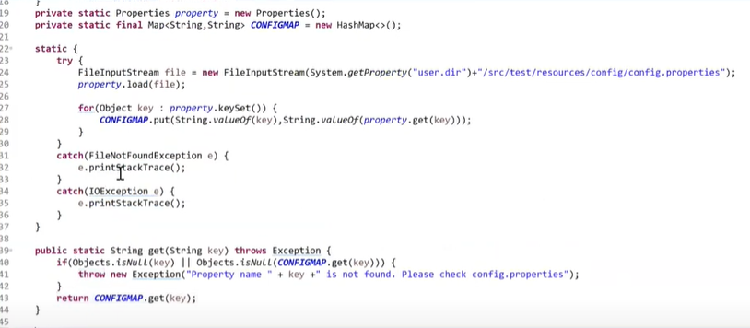

**Using entrySet()**

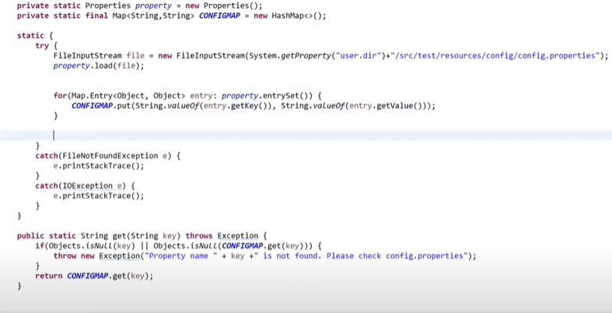

* **AssertJ**

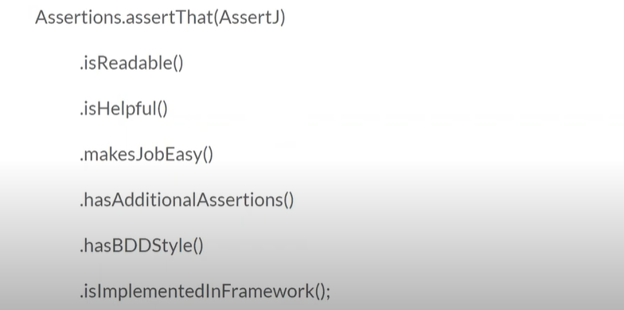

AssertJ is an external library which provides additional assertions like Testng and Junit. The advantage of AssertJ is that it can be used to write multiple assertions for the same element or scenario which is limited in Testng and Junit. Hence reduces the lines of code.

We have to add the dependency for AssertJ in pom.xml. There are additional dependencies for assertj-joda-time which can be used while validating calendar fields.

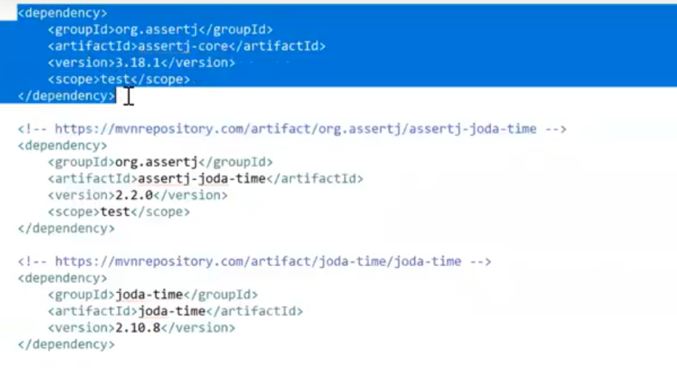

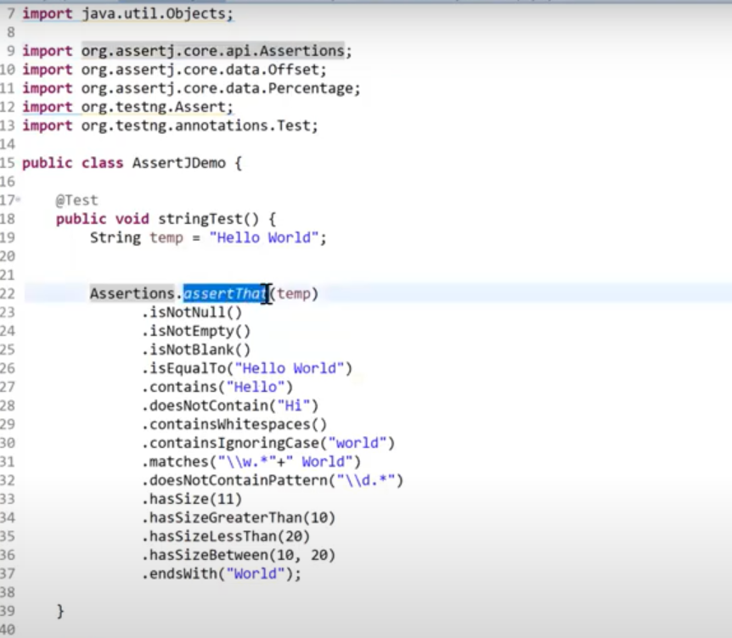

.as method can be used to add comments for specific assertions. But it should come before the assertion, here in this case the assertion is .isNotBlank().

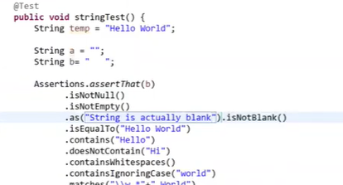

Assetions for numeric datatype

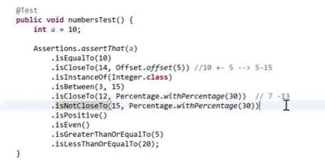

Assetions for List interface.

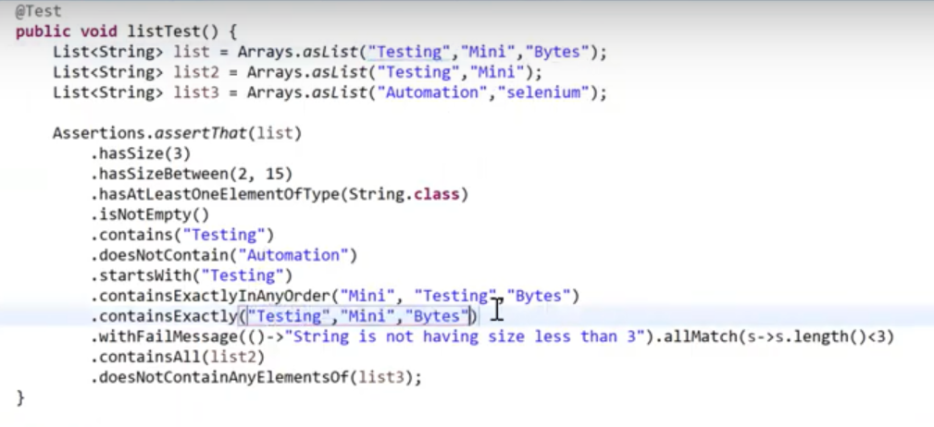

Assertions for map interface.

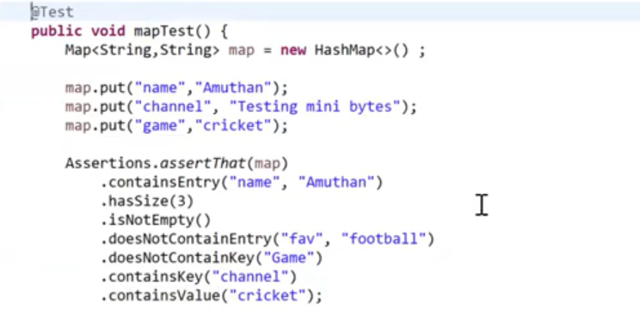

AssertJ also provides soft assertion capabilities.

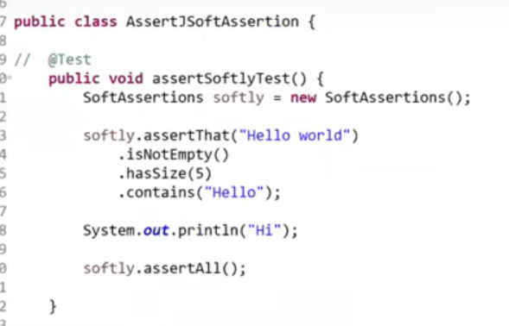

BDD style assetions

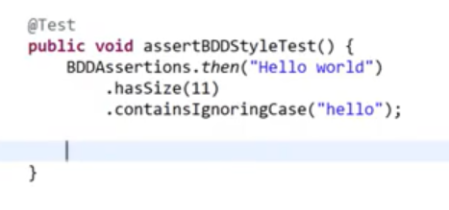

While validating the calendar field we need to import **LocalDate** from **org.joda.time.LocalDate** and **assertions** from **org.assertj.jodatime.api.Assertions**

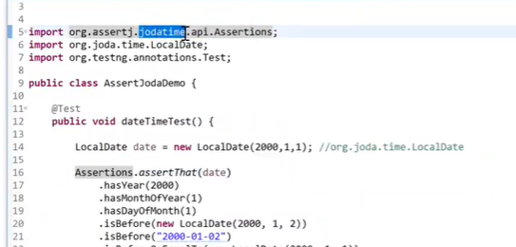

* **Page Class construction**

While creating the page class for its respective Test class, the object repository must be **private** and **final** in nature as it need to be accessed only within the same class and the value is not supposed to change.

The page class must be **final** in nature as this would prevent the class from being extended by other classes. But we **cant create a private constructor** of the page class, as we would need to create the objects of the same in the test classes to access the action methods.

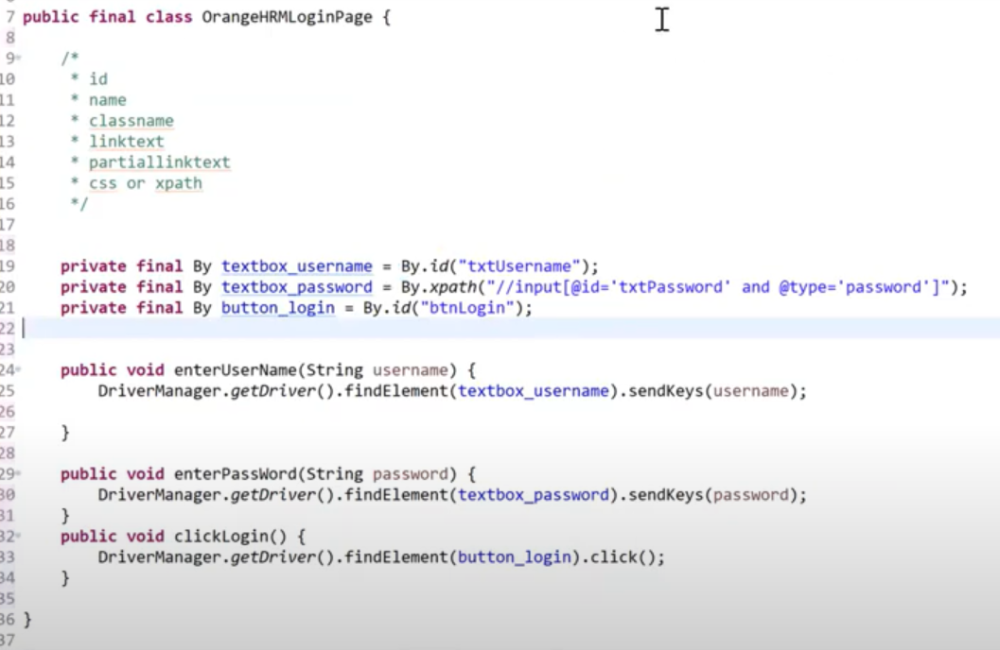

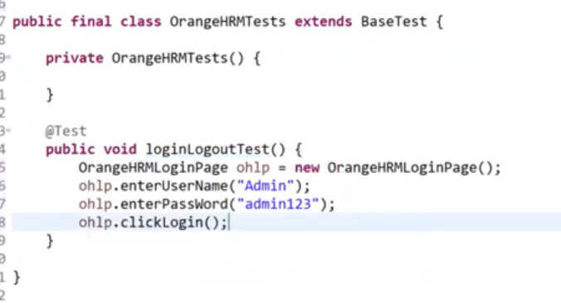

* **Method Chaining and its importance in POM**

Method chaining concept is equally important like Page chaining. But Method chaining is not mandatory like Page chaining and its advantage is that once implemented it considerably reduces the lines of code.

In the below screenshot we can see three lines of code, but once we use method chaining the number of lines of code can be reduced.

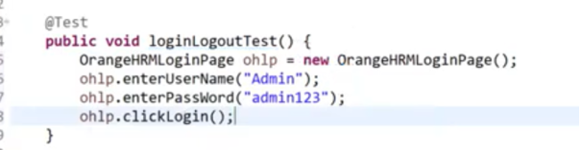

A prime example of method chaining implemented in Selenium is below :

**driver.manage().window().maximize()**

here we are calling multiple methods in a single line itself which mirrors method chaining.

In the below screenshot we can see the changes highlighted in blue. Usually the methods enterUserName and enterPassword doesn’t return any value, **but here to implement method chaining we using this keyword to return the classname OrangeHRMLoginPage** in which these methods reside.

The third method OrangeHRMHomePage implements Page Chaining.

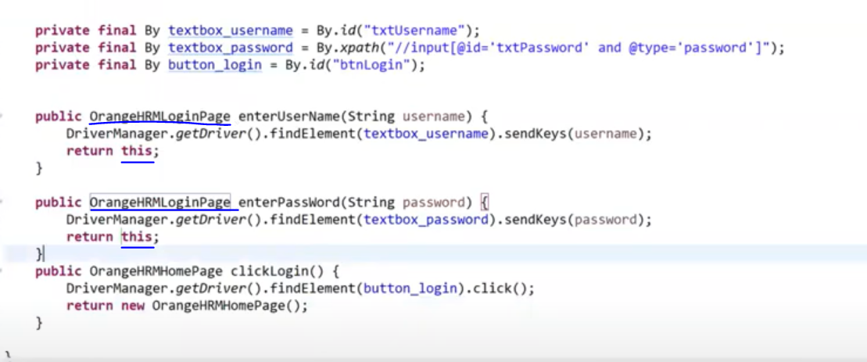

Note – For the methods which returns a specifc datatype, there is no need to implement the above process.

Now in the below screenshot we can see how these changes impact the Test class in reducing the lines of code. In a single line we are able to call all the action methods in its corresponding Page class.

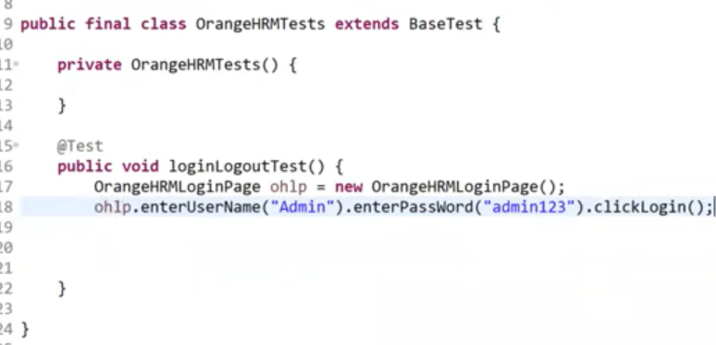

* **Dynamic xpath (a new approach)**

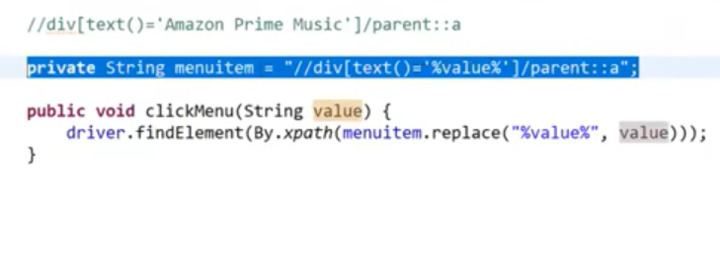

* **Alternative to Thread.sleep**

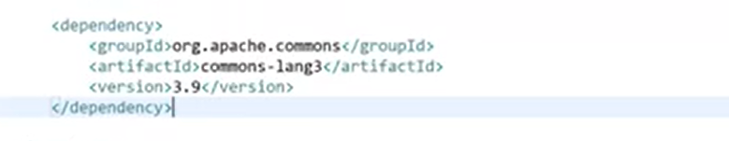

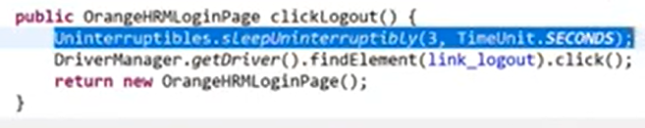

* **When to use Inheritance**

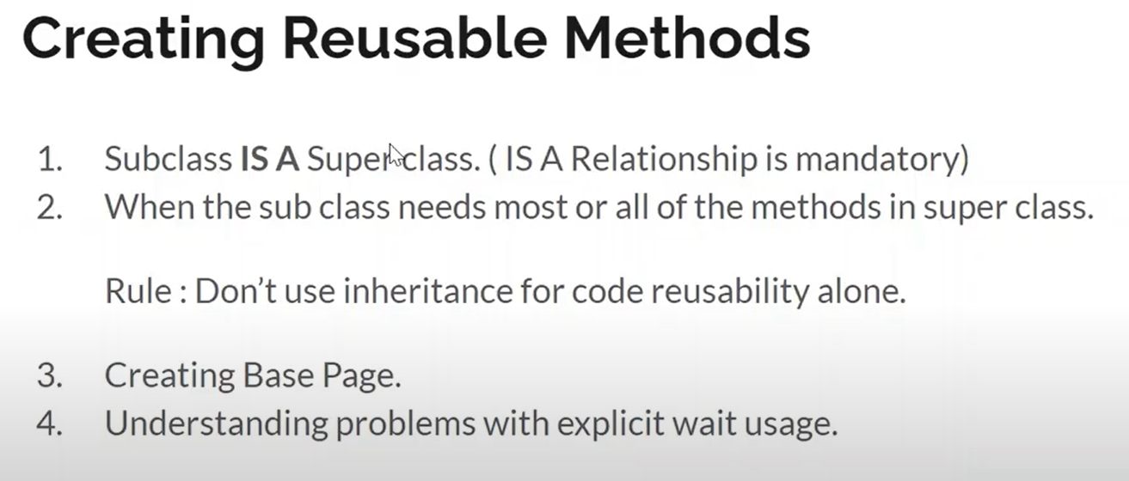

The first point in the above image states that Subclass and the Superclass must have IS A relationship. This means that we need to use inheritance meaningfully and not just for the sake of accessing elements from another class.

OK – We have used inheritance in the test classes. The BaseTest class is inherited by all the Test classes. Here both the subclass and the superclass is created specifically for the functionality ‘Test’ and hence is having an IS A relationship.

Not OK – Not at all recommended to extend the DriverFactory class in any other classes just to get the driver value. This is indeed a wrong practice in test framework creation. If we are doing so then we are not maintaining the IS A relationship as responsibility of DriverFactory class is to handle the driver and for example if DriverFactory is inherited by any Page class, that page class is having responsibility to handle the page layer. Hence here both the subclass and the superclass are following a different responsibility and doesn’t align with the IS A relationship.

**Example** – The reusable methods in the framework can be created in a class which can be named as ‘Commons’ or ‘BasePage’. Here inheritance comes into picture as we can use the reusable methods in any of the Page classes. Hence it is proper to extend the Commons class in the Page classes.

While creating the reusable methods in the Commons class, we cant make their access modifier as **private** as we are extending that class in other Page classes. Hence to maintain a robust framework instead of making it as **public** it is best suited to make it as **protected**.

**Important** – Consider the scenario where Commons is the Superclass and LoginPage is the Subclass, if we are making the reusable methods in superclass (Commons) as **public** then while creating the object of the Subclass in any other class for example(LoginPageTest) we would be able to access the reusable methods in Commons using object of the subclass(LoginPage), this doesn’t make the framework robust. Hence it is perfect to make it as **protected**.

* **Enum**

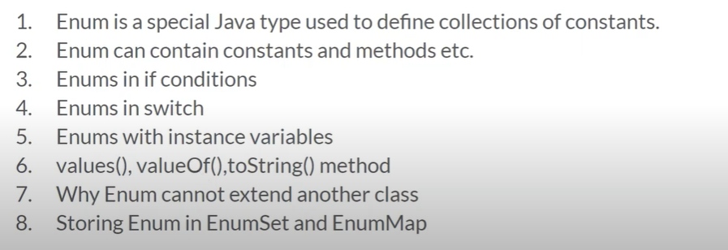

Using Enum we can define a set of constants and manage them easily.

**First line inside the Enum must be the set of constants and only then we can add variables, constructors and methods.**

To be in line with the naming conventions we must define the constant names in **CAPS**.

In the below image we can see how a simple ENUM is defined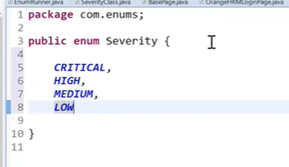

While defining the ENUM like above, internally in Java the ENUM would get stored as below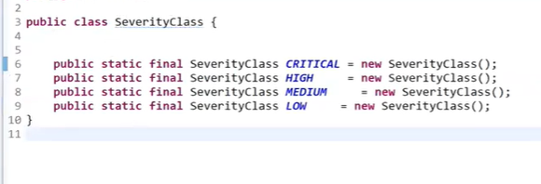

Every ENUM constants gets stored in the memory as **public, static and final**.

**ENUM’s cannot extend any other classes in Java**, because by default it extends **java.lang.Enum** class and as per Java only one class can be inherited at a time.

But **ENUM can implement many interfaces**.

Accessing Enum Values from other Classes -> This can be accomplished as shown in the below image

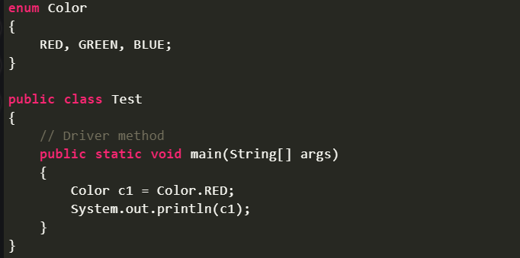

As the Enum constant values are static in nature we can easily access them using the ENUM name.

By default the ENUM object values(Color.RED) fetches a String value. This is because the ENUM class inherits java.lang.Enum.class and **toString()** method is overridden in this class.

Once the enum value is accessed we can store them in an ENUM reference variable (Color c1).

Important ENUM methods – valueOf() and values()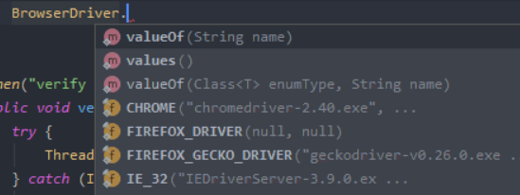

* ValueOf() will return a specific ENUM Constant value
* Values() will return array of ENUM type with all the ENUM Constant values which can be later traversed using foreach loop or iterator.

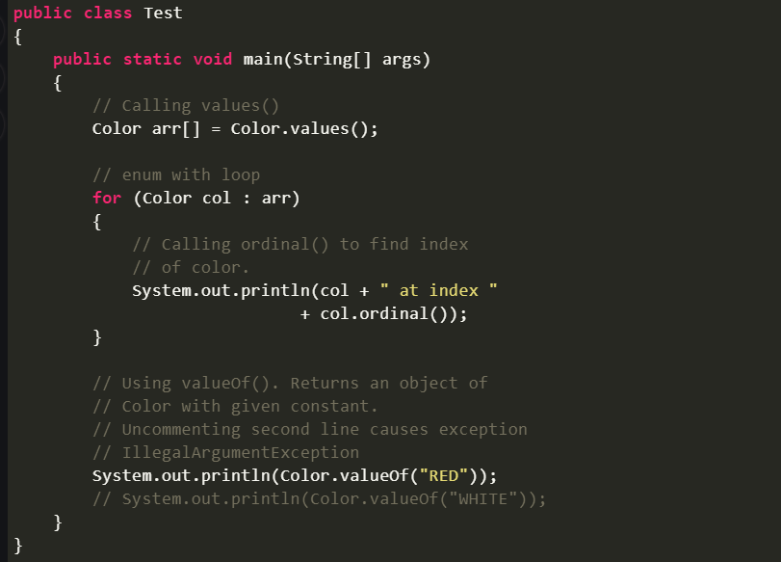

Some more examples of different ways ENUM can be implemented.

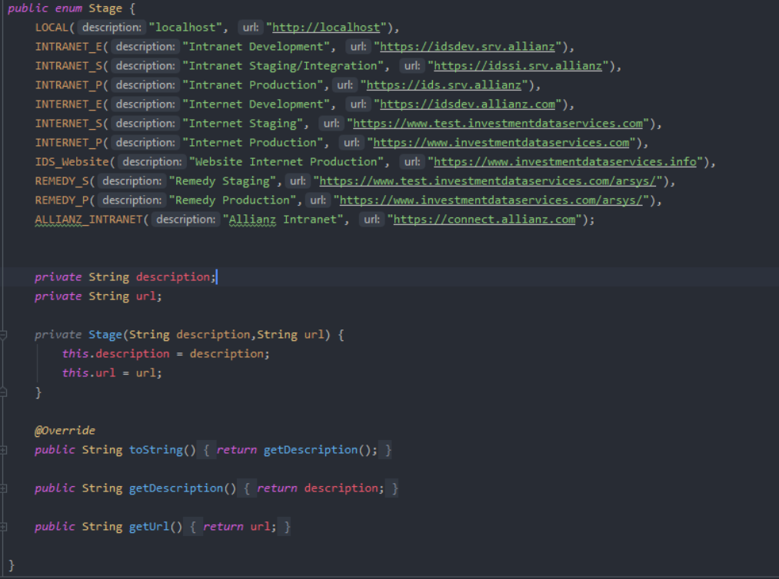 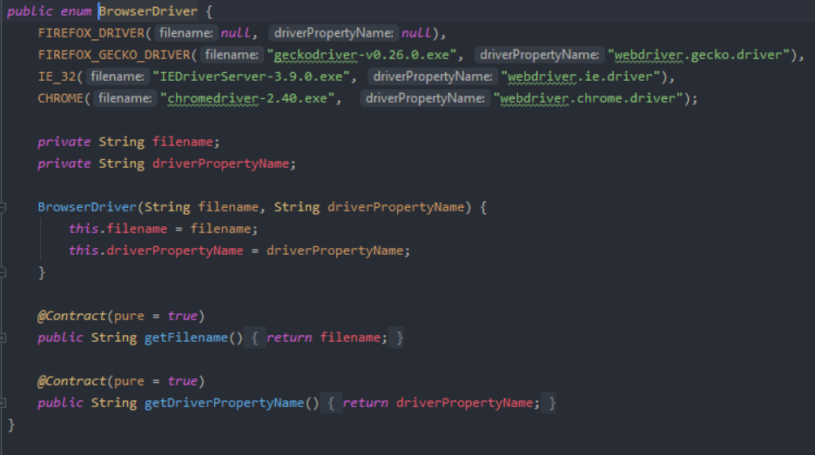

* **Solving Framework problems with Enum**

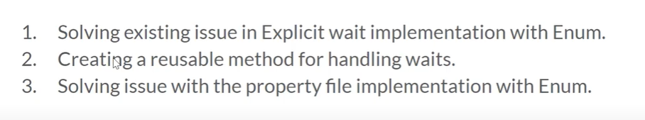

Scenario – In every action method in the Page class, we would have to perform some actions. There would be common actions like sendKeys, click etc and instead of writing them repeatedly for all the action methods we can move the these resuable methods to the BasePage or Common class.

Once the resuable methods are in Common class, each one of them will be having a unique explicit wait condition. But in the application, the same wait condition doesn’t apply for all the click methods.

Hence to incorporate this the first option is to add multiple reusable click methods with different explicit wait conditions. This option is not efficient.

The second option is to add multiple wait checks in ‘if’ condition and parameterize the type of wait that we need for a particular click method. Once this is done, the user can enter the required wait strategy to be included with the method. (as shown below).

**BasePage or Commons class**

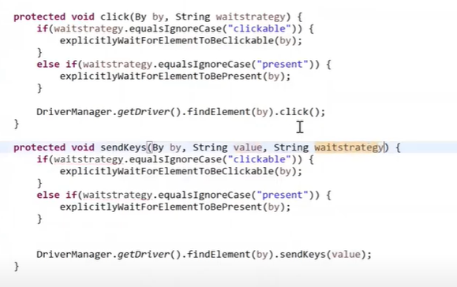

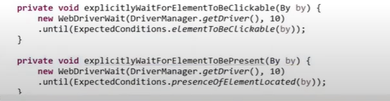

**Page class**

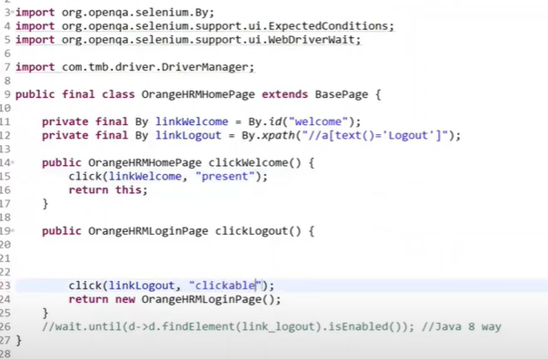

Problem – The above implementation is fine but there are chances of getting runtime exception. If the automation tester is giving “presence” instead of “present” while calling the reusable click method then the test would fail. In a robust framework we must reduce the chances of getting a runtime exception. This implementation can be improved by using **Enums**.

**ADDITIONAL IMPLEMENTATION TWEAK**

We can also move the wait time seconds value in the Commons or Reusable methods to the Constants class, hence the framework user will have the flexibility to effectively change the wait time for all the reusable methods in one go.

AS-IS



NEW Implementation

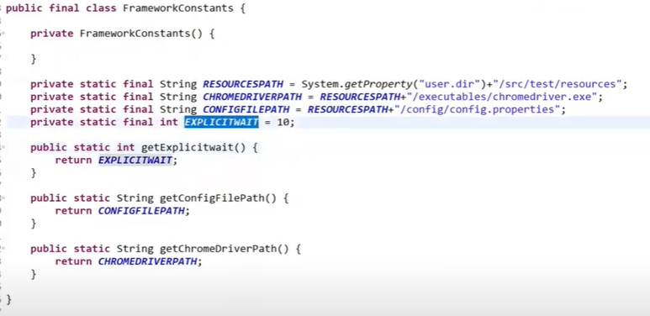

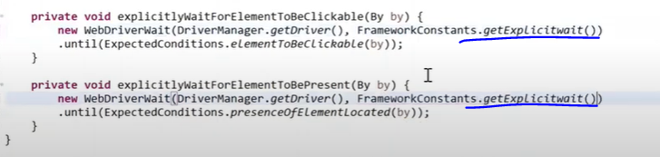

Solution

Create a new package -> new enum(WaitStrategy) in src/main/java. Add the constant collection with what all wait strategy options we want the user to select.

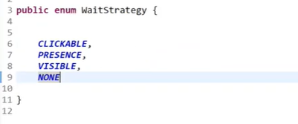

Replace the string value in the Page class with the Enum values. In the below image we can see that only the required options are getting populated which reduces the chances for a runtime exception occurrence.

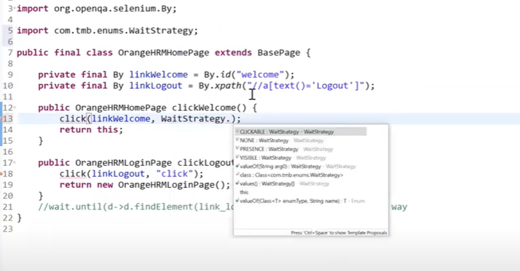

In the below image we have replaced the string values with the Enum constants.

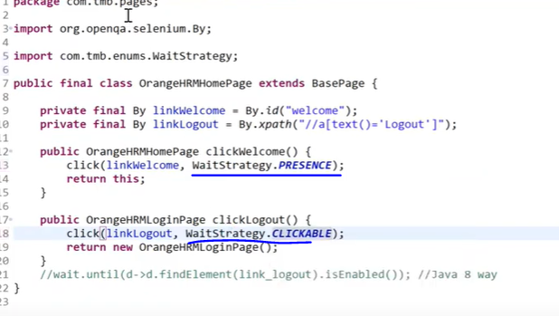

Below we can see the implementation changes for the Enum in the BasePage or Commons class, here we have removed the string value checks in if condition with the desired wait strategy. But here there is a problem which is highlighted in the next image.

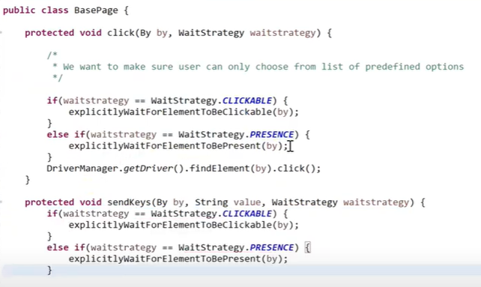

The problem is that the same conditions are getting repeated for each reusable method which is not an optimal approach, hence we need to handle the same.

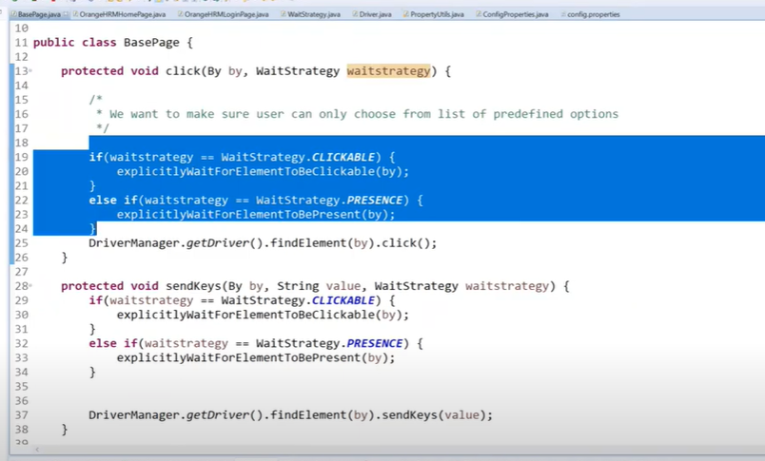



To handle the same we have moved the method highlighted above along with the wait conditions to a separate class – **ExplicitWaitFactory** which would return a Webelement that we can directly perform the required action and no need to add additional lines in BasePage or Commons class.

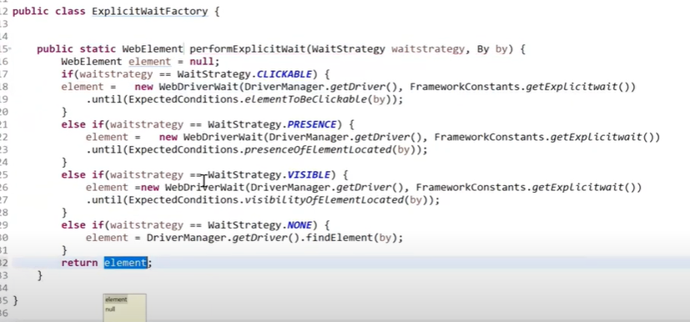

Below is how now the reusables methods look.

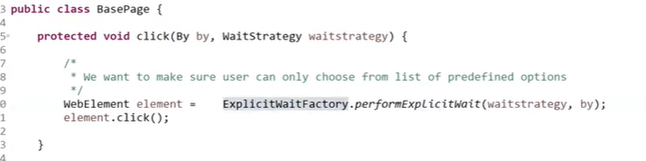

**ADDITIONAL IMPLEMENTATION TWEAK**

As an addon to the above implementation we can also create Enum to handle the url value we are passing in the Driver class. The reason to implement the Enum is because the user can unknowingly give URL instead of url and hence while doing so there would be a runtime exception that is happening and this needs to be avoided to achieve a robust end to end framework.

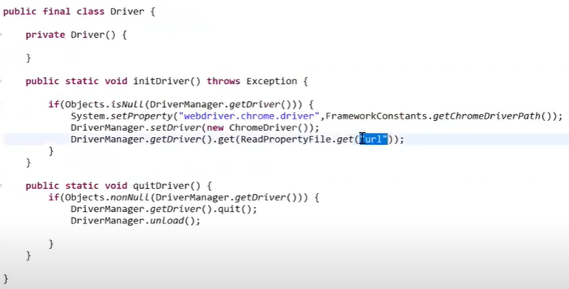

Below is the config.properties file.

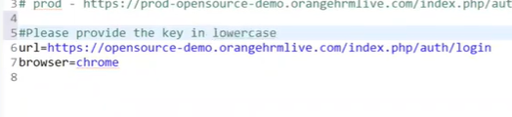

New Enum is created to handle the config.properties file values.

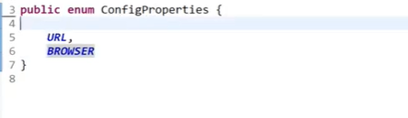

In the ConfigReader or PropertyUtils class the actual implementation accepts a String key.

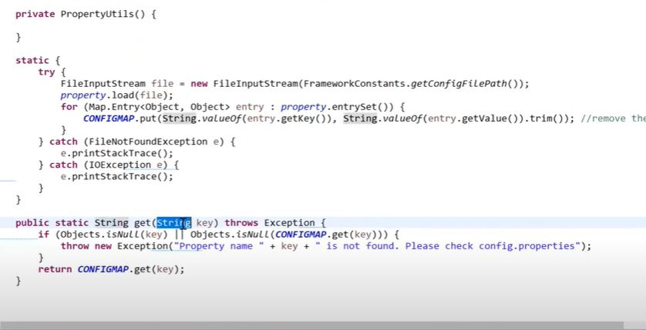

Replace the String datatype with the Enum and instead of returning key put key.name().toLowerCase();

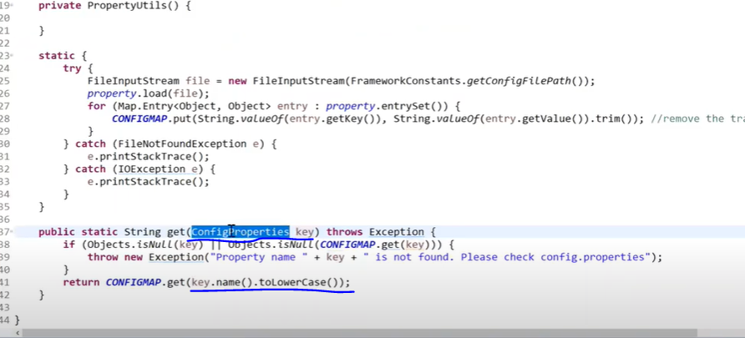

Now to complete the implementation we can remove the “url” String in the Driver class and replace it with the predefined Enum values.

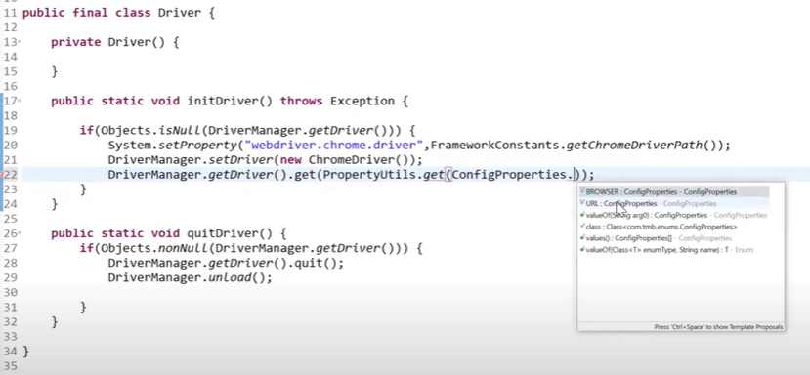

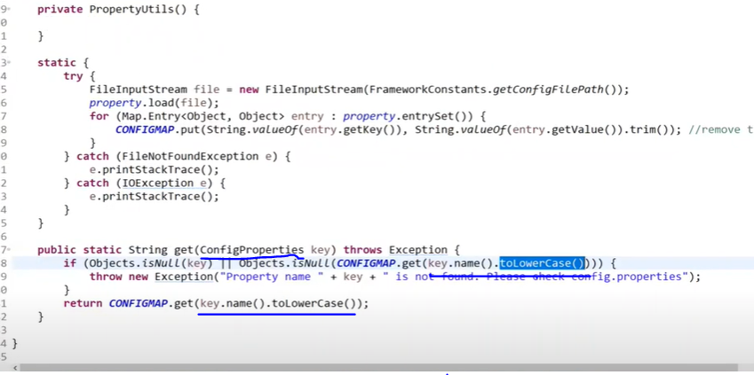

* **Dataprovider**

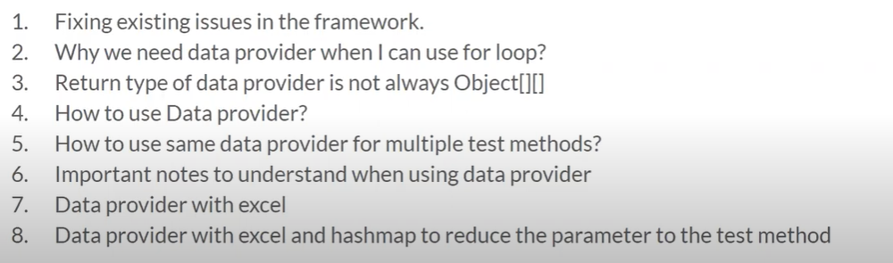

1. Why we need Dataprovider when we can use for loop ?

Dataprovider is used to run a specific test case with n number of test data. This can also be achieved by using for loop, by putting the test data in an array and iterating using for loop but it has the below disadvantages :

If we are using for loop for combination of 10 test data, then we can see that only one test case will get executed. Instead of that if we are using Dataprovider then we can see individual test case for each test data iteration.

Another disadvantage of using for loop instead of Dataprovider is that, if there is an issue with the first test data iteration then the test will show as failed. This will mask all the remaining test data iterations. Once the first issue is fixed then we have to run suite again to see the next iteration is working fine or not.

1. S
2. S
3. S
4. S
5. S
6. S
7. s

* 4
* 5
* 6
* 7
* 8
* 9
* 0
* 1
* 2
* 3
* 4
* 5
* 6
* 7
* 8
* 9
* 0
* 1
* 2
* 3
* 4
* 5
* 6
* 7
* 8
* 9
* 0
* 1
* 2
* 4
* 5
* 6
* 7
* 8
* 90
* 1
* 2
* 3
* 4
* 5
* 6
* 7
* 8
* 9
* 0
* 1
* 2
* 3
* 4
* 5
* 6
* 7
* 8
* 9
* 0
* 1
* 2
* 3
* 4
* 5
* 6
* 7
* 1
* 2
* 3
* 4
* 5
* 6
* 7
* 8
* 9
* 0
* 1
* 2
* 4
* 5
* 6
* 7
* 8
* 90
* 1
* 2
* 3
* 4
* 5
* 6
* 7
* 8
* 9
* 0
* 1
* 2
* 3
* 4
* 5
* 6
* 7
* 8
* 9
* 0
* 1
* 2
* 3
* 4
* 5
* 6
* 7
* 1
* 2
* 3
* 4
* 5
* 6
* 7
* 8
* 9
* 0
* 1
* 2
* 4
* 5
* 6
* 7
* 8
* 90
* 1
* 2
* 3
* 4
* 5
* 6
* 7
* 8
* 9
* 0
* 1
* 2
* 3
* 4
* 5
* 6
* 7
* 8
* 9
* 0
* 1
* 2
* 3
* 4
* 5
* 6
* 7
* 1
* 2
* 3
* 4
* 5
* 6
* 7
* 8
* 9
* 0
* 1
* 2
* 4
* 5
* 6
* 7
* 8
* 90
* 1
* 2
* 3
* 4
* 5
* 6
* 7
* 8
* 9
* 0
* 1
* 2
* 3
* 4
* 5
* 6
* 7
* 8
* 9
* 0
* 1
* 2
* 3
* 4
* 5
* 6
* 7
* 1
* 2
* 3
* 4
* 5
* 6
* 7
* 8
* 9
* 0
* 1
* 2
* 4
* 5
* 6
* 7
* 8
* 90
* 1
* 2
* 3
* 4
* 5
* 6
* 7
* 8
* 9
* 0
* 1
* 2
* 3
* 4
* 5
* 6
* 7
* 8
* 9
* 0
* 1
* 2
* 3
* 4
* 5
* 6
* 7
* 1
* 2
* 3
* 4
* 5
* 6
* 7
* 8
* 9
* 0
* 1
* 2
* 4
* 5
* 6
* 7
* 8
* 90
* 1
* 2
* 3
* 4
* 5
* 6
* 7
* 8
* 9
* 0
* 1
* 2
* 3
* 4
* 5
* 6
* 7
* 8
* 9
* 0
* 1
* 2
* 3
* 4
* 5
* 6
* 7
* 1
* 2
* 3
* 4
* 5
* 6
* 7
* 8
* 9
* 0
* 1
* 2
* 4
* 5
* 6
* 7
* 8
* 90
* 1
* 2
* 3
* 4
* 5
* 6
* 7
* 8
* 9
* 0
* 1
* 2
* 3
* 4
* 5
* 6
* 7
* 8
* 9
* 0
* 1
* 2
* 3
* 4
* 5
* 6
* 7
* 1
* 2
* 3
* 4
* 5
* 6
* 7
* 8
* 9
* 0
* 1
* 2
* 4
* 5
* 6
* 7
* 8
* 90
* 1
* 2
* 3
* 4
* 5
* 6
* 7
* 8
* 9
* 0
* 1
* 2
* 3
* 4
* 5
* 6
* 7
* 8
* 9
* 0
* 1
* 2
* 3
* 4
* 5
* 6
* 7